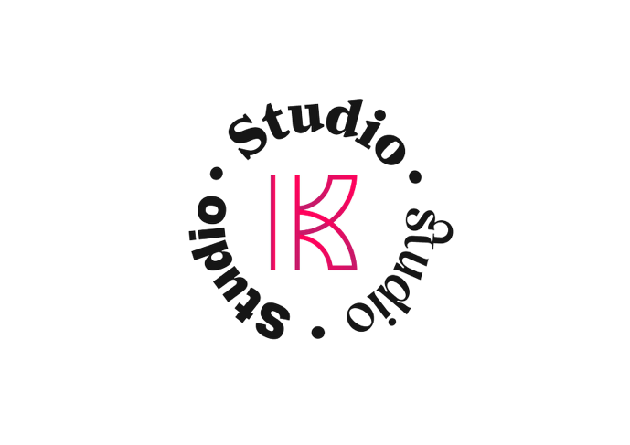

Mid Weight Graphic Designer

Who we are:
We are the creative agency building creative legacies across the UK and Ireland. We champion audacious entrepreneurs and disruptive brands pushing boundaries. We are a collective of strategists, designers, and innovators united by the goal of delivering uncompromising quality and measurable impact. Each member brings the expertise required to turn a brief into a bold market statement.

The Role:
As a Mid-Weight Designer at Kaizen Studio, you’ll be in the thick of it. Building brands, shaping campaigns and creating work people actually notice.
You’ll be hands-on across a mix of client and internal projects. You’ll help bring our clients’ brands to life while also shaping and evolving the Kaizen Studio brand itself. This will be everything from a printed flyer to large-scale campaigns.
Working alongside the Head of Design and wider creative team, you’ll deliver high-quality work across brand, print and campaign outputs. You’ll also support design needs across the wider group, ensuring everything we produce is considered, consistent and on point.

What you’ll be doing
• Creating bold, effective designs across brand, campaigns and digital projects
• Bringing our clients’ brands to life across multiple touch points
• Presenting to clients, explaining your thinking and approach
• Helping shape and evolve the Kaizen brand through internal content and marketing
• Supporting design across the wider group, from creative to print-ready execution
• Designing everything from printed brochures and presentations to campaign rollout and social assets
• Working closely with creatives, account managers and production to get work out the door properly
• Collaborating with clients and external partners when needed
• Keeping standards high and consistency tight across everything we produce

What We’re Looking For
• A solid mid-weight with a strong portfolio of real work
• Someone who cares about ideas just as much as execution
• Detail-obsessed but fast-moving
• Comfortable working on formats across both digital and print
• A team player who’s up for pushing the work further
• Comfortable taking the lead, managing projects from concept to execution

